Week 3/30-4/3-Remote Learning
Lesson Plan Theme: Easter
(additional links/resources/ideas at bottom of page)

Monday 3/30:
Activity ideas/suggestions-cutting practice-cut up old mail, sorting toys by numbers and colors, writing first and last name, baking (math-recipe, measuring, etc), science experiments, READ & PLAY!
-Virtual Field Trips and Apps for At-Home Learning (attached)
-Mrs. Hicks’ P.E. Lesson for Week 2 is below:
https://ses-pe.weebly.com/remote-physical-education.html
Tuesday 3/31:
-Watch Circle Time Video/Number Review/Big Book-Phonics Video on Facebook
-Song Video on Facebook with Ms. Sue to the tune of “If You’re Happy and You Know It”
-Read A Color of His Own by Leo Lionni, 1997 (read by Ms. June!-video on Facebook)
-March Name Writing/Self-Portrait for Scrapbooks (see video on Facebook)--children will write their name on a piece of paper for March and draw their self-portrait on a separate piece of paper for scrapbook
-Art with Mrs. Weiss- (See pic below and email to aweiss@stedward.org)
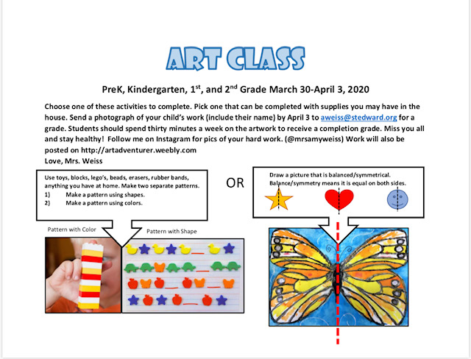
Tuesday 3/31 continued:
-Easter Egg Movement Game (you can print these off if you have a printer and/or write them down on paper and stuff them in plastic Easter Eggs) or just call them out for your child to do!
https://www.tobeakidagain.com/spring-movement-game-using-plastic-eggs-free-printable-action-cards/?utm_medium=social&utm_source=pinterest&utm_campaign=tailwind_tribes&utm_content=tribes&utm_term=321871108_9625256_112125
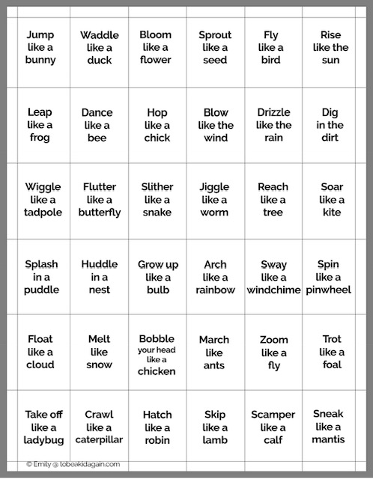

Wednesday 4/1:
-Watch Circle Time Video on Facebook-Letter of the Week: N
-N Literacy Story, Noisy Newt/Charting N’s (video on Facebook)
-N Writing Sheet/Circle N’s on story sheet (sent home with other worksheets)
-Song Video to the tune of “He’s Got the Whole World in His Hands” with Ms. Sue (see video on Facebook)
-Activity Idea (if you have plastic Easter Eggs on hand-or this can be done with any type of blocks, legos, etc)-STEM Easter Egg Tower-stack egg halves and count how many you can get without it falling. Make patterns with the colors too!
https://www.theresourcefulmama.com/plastic-easter-egg-towers-stem-challenge/
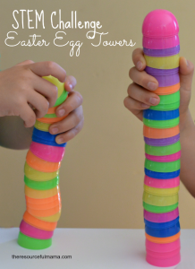

Thursday 4/2:
-Watch Circle Time Video on Facebook/Big Book (Phonics)
-Read The Story of Creation Religion Sheet (video on Facebook)/Easter
-Discussion Questions-1. Why did God create the world? 2. Who did God tell to take care of the world? 3. Tell ways you can help to take care of God’s world.
-Journals-draw a way you can help take care of God’s world (parents or child can write description)
-Additional Journal Entry-Choose 3 friends in our class who you want to pray for and write their names in your Journal. Pray for them at bedtime.
-The Story of Easter video https://youtu.be/HL8R158Ujp4
-Activity Idea: Make a cross (like children did last week with the letter “M”) out of something in your house-art materials, cereal, beads, sticks, construction paper, etc.
-Optional Zoom Meeting with class-10:00 am (will send invite to join)

Friday 4/3:
-Watch Circle Time Video on Facebook
-Read-Aloud Book (see video on Facebook) The Bunny Hop by Teddy Slater (1992)
-Finger Puppet Song, Easter Bunnies
-Science Experiment with Marshmallow Peeps (video on Facebook)
-Palm Sunday reading and craft (see video on Facebook)
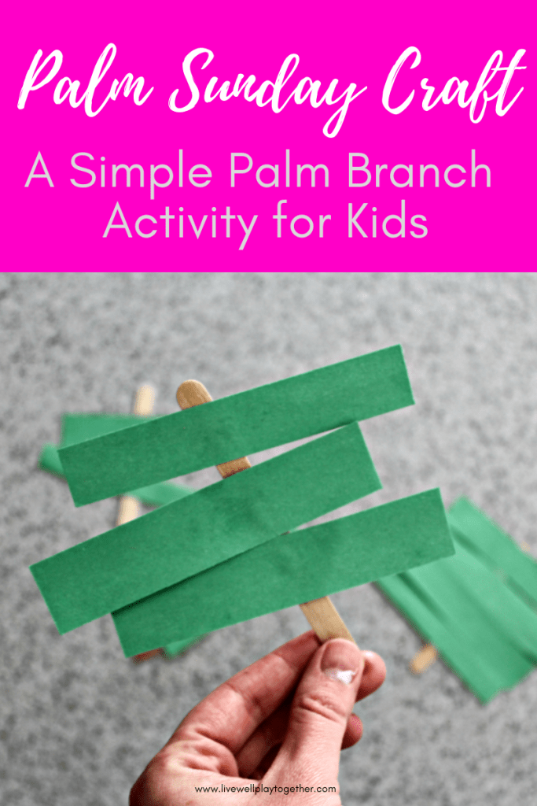

References:
“Plastic Easter Egg Towers Stem Challenge.” The Resourceful Mama, 18 Apr. 2017, www.theresourcefulmama.com/plastic-easter-egg-towers-stem-challenge/.
“Spring Movement Game Using Plastic Eggs + Free Printable Action Cards.” Creative Little Explorers, 23 Mar. 2018, www.tobeakidagain.com/spring-movement-game-using-plastic-eggs-free-printable-action-cards/?utm_medium=social&utm_source=pinterest&utm_campaign=tailwind_tribes&utm_content=tribes&utm_term=321871108_9625256_112125.
Silverstone, Jenny. “25 Fun Fingerplay Ideas for Playful Preschoolers.” Mom Loves Best, Mom Loves Best, 16 Jan. 2020, momlovesbest.com/blog/fingerplay-ideas-for-preschoolers.
The Bunny Hop by Teddy Slater (1992)
A Color of His Own by Leo Lionni, 1997
“Saddleback Kids.” YouTube, YouTube, www.youtube.com/channel/UCEbM1vIWVubIANRR54YuS0g.
Frazier, Karen. “Palm Sunday for Children.” LoveToKnow, LoveToKnow Corp, kids.lovetoknow.com/palm-sunday-children.

Additional Educational Resources:
National Geographic Kids
https://kids.nationalgeographic.com/
BrainPop Jr
Username: stedwardsaints
Password: saints1
https://jr.brainpop.com/
ABC Mouse
Create a (free) account using your personal email address and a password of your choice.
www.ABCmouse.com/redeem
Use code: S C H O O L 7 3 5 3
StarFall
Letters, Letter Sounds, Colors and Shapes
https://www.starfall.com/h/index-kindergarten.php
Jack Hartman
https://www.youtube.com/channel/UCVcQH8A634mauPrGbWs7QlQ
Storyline Online
https://www.storylineonline.net/
Cosmic Kids Yoga Videos
https://www.cosmickids.com/
Additional Ideas to Promote Learning in Literacy, Math, Fine Motor Skills:
-Practice writing first/last name
-Counting/Sorting/Make Patterns-M&M’s, Gummy Bears, Skittles, etc.
-Making letters/numbers out of pipe cleaners or Wiki sticks
-Board games -Baking -READ daily! -Sidewalk Chalk creations outside
-Playdough-Cutting-cut up old mail/scarp paper into shapes, strips, etc.-Nature Walk/Scavenger Hunt

