Week 3/23-3/27-Remote Learning
Lesson Plan Theme: Birds/Spring
(additional links/resources/ideas at bottom of page)

Monday 3/23:
-Watch Intro/Circle Time Video/Big Book-Phonics (These videos will be posted by 8:30 am every morning at the latest)
-Journals (these were sent home)-Draw something you did on Spring Break and write about it (parent help)
-Activity Idea: ABC Scavenger Hunt throughout the house-this can be done with magnet letters, puzzle pieces, handwritten on pieces of paper, etc.—Parents hide letters throughout the house. When child finds a letter, have them recite that letter and make the letter sound.
-Practice “Our Father” and “Angel of God” Prayers (see below)
Our Father, Who art in heaven, hallowed be Thy name; Thy kingdom come; Thy will be done on earth as it is in heaven. Give us this day our daily bread; and forgive us our trespasses as we forgive those who trespass against us; and lead us not into temptation, but deliver us from evil. Amen
Angel of God, my guardian dear, to whom God's love commits me here, ever this day be at my side, to light and guard, to rule and guide. Amen
Tuesday 3/24:
-Watch Circle Time Video on Facebook-Letter of the Week: M
-M Literacy Story/Charting “M” (video on Facebook)
-M Writing Sheet/Circle Mm’s on story sheet (sent home in Wednesday Folders/attached to Journal)
-Activity Idea: Use something in your house-cereal, beads, dry beans, stickers, shaving cream on an oven sheet, pipe cleaners, etc to make the letter “M”.
-Practice “Our Father” and “Angel of God” Prayers (see above)

Wednesday 3/25:
-Watch Circle Time Video on Facebook/Big Book-Phonics
-Birds Intro-read-aloud book (video on Facebook)
-Link below is for bird calls, go outside and listen
-https://www.youtube.com/watch?v=mfFldO-B8vE
-Optional Activity: Make binoculars out of toilet paper rolls, tape to use while bird watching
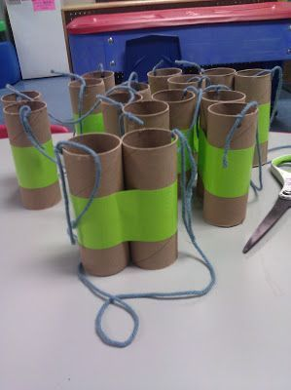
-Take Journal outside and draw a bird(s) that you see
-Video on Facebook with Little Bird song with felt board puppets
-Practice “Our Father” and “Angel of God” Prayers
Our Father, Who art in heaven, hallowed be Thy name; Thy kingdom come; Thy will be done on earth as it is in heaven. Give us this day our daily bread; and forgive us our trespasses as we forgive those who trespass against us; and lead us not into temptation, but deliver us from evil. Amen
Angel of God, my guardian dear, to whom God's love commits me here, ever this day be at my side, to light and guard, to rule and guide. Amen

Thursday 3/26:
-Watch Circle Time Video on Facebook/Big Book-Phonics
-The Tiny Seed by Eric Carle (this is a link to listen/see this book being read on You Tube—I did not have it at home)
https://www.youtube.com/watch?v=I_A_e6h-DhU
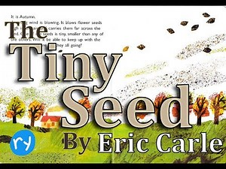
Activity:
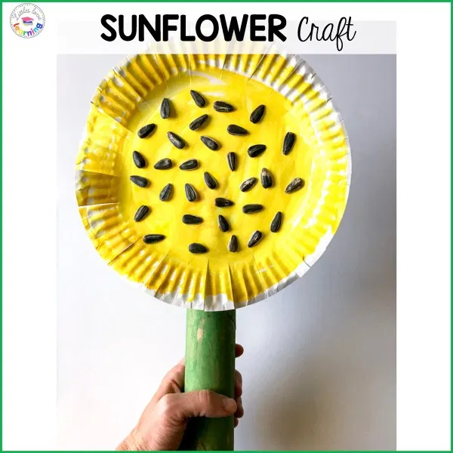

Thursday 3/26 continued:
Supplies:
- Paper towel roll
- White paper plate
- Sunflower seeds-this can just be using a black marker or crayon or cut up pieces of black construction paper glued on
- Markers/Crayons/Paint {yellow and green}
- Glue/Tape
Directions:
- Have your little one color/paint the paper plate yellow and the paper towel roll green.
- Either color/glue seeds onto paper plate
- While coloring/gluing on your sunflower seeds, you can talk about the seed from the story and its journey through the seasons.
- Last, glue/tape the paper plate to the paper towel roll.
- Hang up your little one’s sunflower and see how proud they are of their work!

Friday 3/27:
-Watch Circle Time Video on Facebook
-Book-read-aloud video on Facebook, Little Loon and Papa by Toni Buzzeo
-Movement Songs/Videos on Facebook
-S.T.E.M. Activity-Build a Bird’s Nest (link below)
-Supplies-paper plate, scissors, natural materials-twigs, grass, leaves, moss, etc, string/yarn
https://kidscraftroom.com/make-a-birds-nest-steam-project/
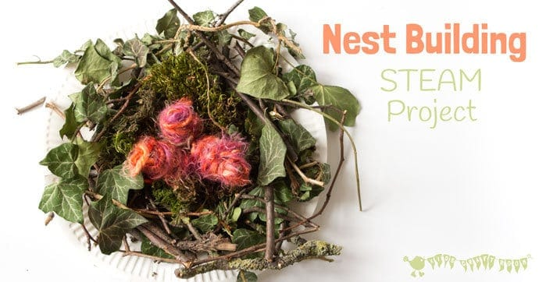
These are pictures of a real bird’s nest from my backyard back in June this past Summer.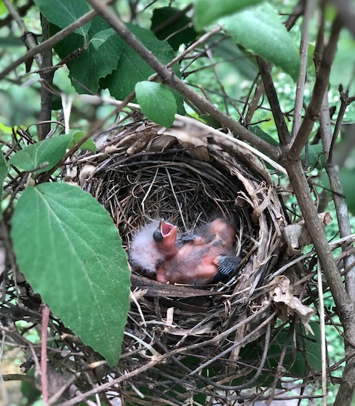 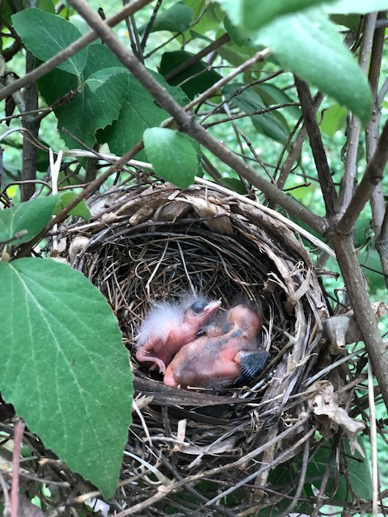

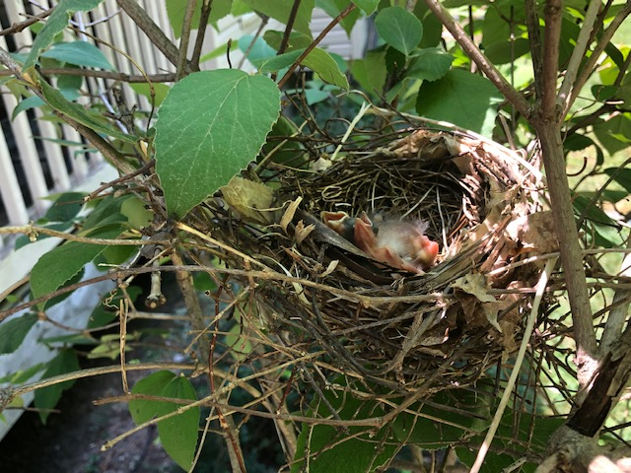
Additional Educational Resources:
National Geographic Kids
https://kids.nationalgeographic.com/
BrainPop Jr
Username: stedwardsaints
Password: saints1
https://jr.brainpop.com/
ABC Mouse
Create a (free) account using your personal email address and a password of your choice.
www.ABCmouse.com/redeem
Use code: S C H O O L 7 3 5 3
StarFall
Letters, Letter Sounds, Colors and Shapes
https://www.starfall.com/h/index-kindergarten.php
Jack Hartman
https://www.youtube.com/channel/UCVcQH8A634mauPrGbWs7QlQ

Additional Ideas to Promote Learning in Literacy, Math, Fine Motor Skills:
-Practice writing first/last name
-Counting/Sorting/Make Patterns-M&M’s, Gummy Bears, Skittles, etc.
-Making letters/numbers out of pipe cleaners
-READ daily!
-Draw pictures/make cards and mail to their family/friends
-Sidewalk Chalk creations outside
-Playdough
-Cutting-cut up old mail/scarp paper into shapes, strips, etc.
-Nature Walk/Scavenger Hunt

