Week 4/6-4/10 Remote Learning
Lesson Plan Theme: Holy Week/Easter

Monday 4/6:
Holy Week Family Retreat.pdf-great resource from Jennie Guinn, Director of Religious Education
-Mrs. Weiss’ Art Class Assignment (posted on Facebook):
https://artadventurer.weebly.com/

Tuesday 4/7:
-Watch Circle Time Video on Facebook
-Read The Week That Led to Easter by Joanne Larrison-see video on Facebook
-Results for Marshmallow Peeps Science Experiment-48 hours (2 days)-see video on Facebook
-Writing Activity-Easter Bible Verses: Print off if you have a printer-trace the bible verse and then student can try and write it on their own underneath traced verse. OR parent write it for them in Journal and have them copy it underneath. May want to spread this out in a few sittings if it is too much writing at once.
https://3boysandadog.com/wp-content/uploads/2014/03/Easter-Quotes-Handwriting-Sheet-.pdf
-Journal-Draw an Easter Egg and Make a Pattern (ie: green, yellow, green, yellow) (example below but can make your own/also a picture in video on Facebook)
-Movement: Easter Bunny Dance & Freeze by Jack Hartman https://www.youtube.com/watch?v=nZFRg1GucZ8
Wednesday 4/8:
-Watch Circle Time Video on Facebook
-Results for Marshmallow Peeps Science Experiment-78 hours (3 days)-see video on Facebook
-Read The Resurrection Story with Easter Eggs (see video on Facebook-if you have plastic Easter Eggs, create your own Resurrection Story with the items that were used and retell the story to your parents/siblings).
-Read Curious George and the bunny by Margaret & H.A. Rey (video on Facebook-by Ms. June)
-IfIWeretheEasterBunnyFreebie.pdf Activity-print out if you have a printer-if not, parent can ask questions and student can draw pictures/write answers in Journal.
https://downloads.teacherspayteachers.com/1/1768/1768232/7d4f82cf557448a755f7557ffb7aba5b?rN5Py0XPMTZlsG7bqTKtqkFsAaXgZwM-7mNklQjq1EbeBtUSaLnos7SGvelR6BVZmXrOEyaEmcNunxNaHm1nPnbxa6nFOQIk5uf4ymmktHT1Z7hk60EDQ2Hs_VL7ytOOpcjIsR6AiKdu3kRdzcA&file_name=IfIWeretheEasterBunnyFreebie.pdf
-Mrs. Hicks’ P.E. Class:
https://ses-pe.weebly.com/remote-physical-education.html
-Optional Zoom Meeting at 10:00 am-SHOW & TELL!

Thursday 4/9:
-Watch Circle Time video on Facebook
-Read My Easter Basket And the true story of Easter by Mary Manz Simon (video on Facebook)
Stations_of_the_Cross_List.pdf
-Holy Thursday-We encourage the entire school to watch Stations of the Cross at 11:00 am as if we were at school participating together. Link below.
https://www.youtube.com/watch?v=H86KVT4rzP8&feature=youtu.be
-The Tale of Peter Rabbit written and illustrated by Beatrix Potter-website below to watch video of book being read by actor Rose Byrne (link below)/additional activities under “Teacher’s Guide” https://www.storylineonline.net/books/peter-rabbit/
-Draw your version of Peter Rabbit in Journals
Good Friday-Easter Monday-No School/Easter Holiday
Easter Weekend/Monday Project:
Be A Light of Christ
In an effort to provide light in the world where there is so much uncertainty and worry, the St. Edward School family will have the chance to participate in a kindness activity each week to share the light of Christ with those around them.
Our first "Be a light of Christ" activity will be "showcased" on Easter Monday. All students are encouraged to participate with their family to provide hope and encouragement for their neighbors, friends and families. Our first activity is to create a positive message by drawing a picture, writing encouraging words or a Bible verse with chalk on your driveway or sidewalk. Or you can share your message by writing on a piece of paper and hanging it on your mailbox or front door. Please take a picture and share it with your teacher. We will share the pictures with our SE community.

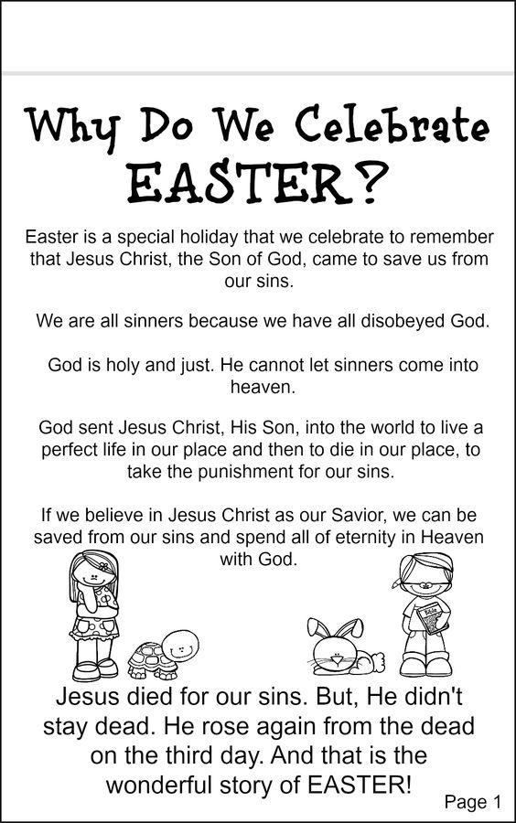

Resources:
Miller, Kelli. “Homepage.” 3 Boys and a Dog, 17 Mar. 2020, 3boysandadog.com/.
JackHartmann. “Jack Hartmann Kids Music Channel.” YouTube, YouTube, www.youtube.com/user/JackHartmann.
“If I Were the Easter Bunny.” Teachers Pay Teachers, www.teacherspayteachers.com/Browse/Search:if%20i%20were%20the%20easter%20bunny.
“1-2-3 Catholic.” YouTube, YouTube, www.youtube.com/channel/UCSCJH4GnHF_Hl9LM9qL5Y4Q.
You Are Being Redirected..., www.storylineonline.net/books/peter-rabbit/.

