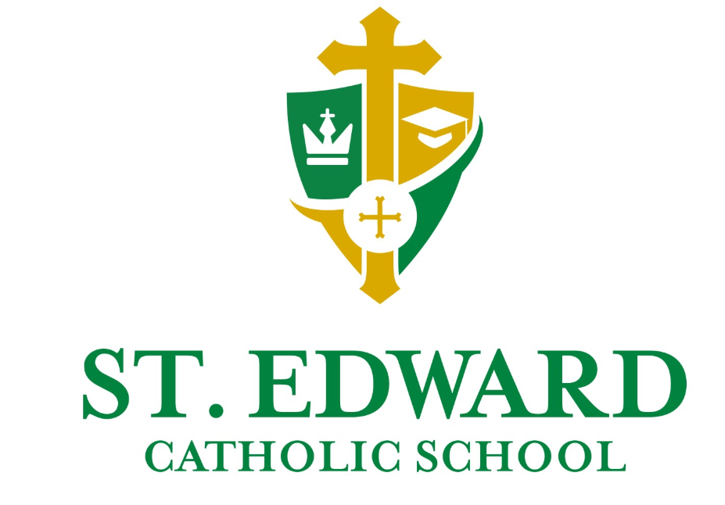

March 27, 2020

Dear Parents,

Attached you will find a summary of your child’s learning plan for the week of March 30 - April 3. As teachers, we will continue to provide the best education possible for your child, under these circumstances. We know though, that each of your situations is different and each family has its own set of challenges. Please know that we understand.
The health and stability of your family needs to be your first priority.

Based on parent feedback, there will be adjustments to this week’s schedule. We are only scheduling planned lessons this week for four days, Tuesday – Friday. On Monday, have your child review or finish activities from this week, practice math facts, read a book of their choice, visit one or two of the many virtual field trips or on-line activities available, help with chores around the house, play board games with a sibling, bake cookies, or play out in the yard. We have included some additional resources at the bottom of this document.

On the remainder of the days, you may see more interactive formats for lessons being used such as ZOOM or Microsoft Teams, so that students can see, hear and interact with teachers and their classmates. If you are experiencing, challenges based on parents working from home, children sharing computers, or just not understanding the work, please contact your child’s teacher and modifications will be made. If a teacher has not received communication from a student for more than two days, they will be calling to see how they can help your child get back on track. Principals throughout the diocese are working on collective guidelines for specific topics such as attendance and grading with administrators in the Superintendent’s office. These will be shared with parents when established.
More important than academic progress, though, is our continued faith in God through these trying times. In addition to the Religion curriculum that will still be presented to your child, Jennie Guinn, Director of Religious Education will present resources for parents to support their children’s continued growth in the faith. Jennie’s resource will be listed under Faith Formation on the church website.

Melissa Smith, counselor, has resources for parents on the counselors’ public Facebook group. Click here to access that page.

May God’s continued blessings be with you and your families.

Marsha Wharton, Principal

* * * * * * *
Educational Apps to Supplement Student Learning

(insert here)

* * * * * * * *

*

Learning Plans for the Week

(insert here)

Virtual Field Trips

https://stedwardorg-my.sharepoint.com/:w:/g/personal/aweiss_stedward_org/ETrm4Vyzv-9LqerxdvXFKAQB0ej4Ph4NOMKyG-c4SHejvw?e=4%3AHZKZwL&at=9&CID=6f082ccf-9a86-20c2-0334-c02e8410f753

